Required packages for the program

These Python (version 3.8.5) packages are used for the program:

pandas
os (default package in Python)
sys (default package in Python)
numpy
matplotlib
scikit-learn (imported as sklearn)
datetime (default package in Python)

To install non-default packages with pip, these commands should be executed:

pip install pandas
pip install numpy
pip install matplotlib
pip install scikit-learn

or

pip3 install -U numpy
pip3 install -U pandas
pip3 install -U matplotlib
pip3 install -U scikit-learn

To install non-default packages with conda, these commands should be executed:

conda install -c conda-forge numpy
conda install -c conda-forge pandas
conda install -c conda-forge matplotlib
conda install -c conda-forge scikit-learn

Training and testing files for the program

To be able to use, the training file (poker-hand-training-true.data) and testing file (poker-hand-testing.data) must be in the same folder with the program. Both files are downloaded from https://archive.ics.uci.edu/ml/machine-learning-databases/poker/

How program works

1) The program creates the log file (if doesn’t exist), and writes the date and time.

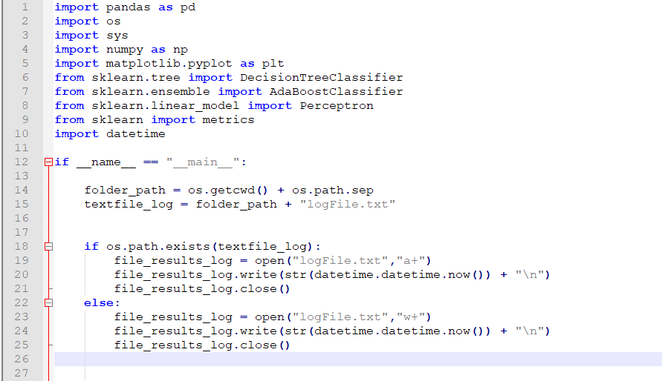
2) The program checks the existence of training and test files. If one of them is absent, the program finishes.
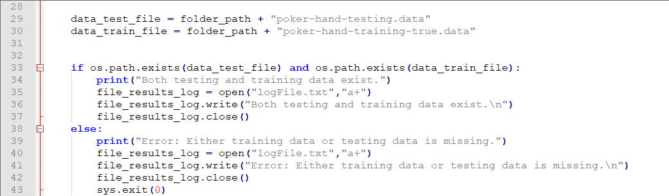
3) The program reads the .data files.

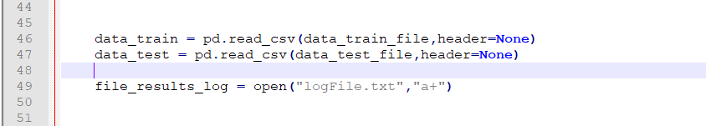
4) Due to the fact that in the homework we need only 2 values (0 – None in the hand and 1 – Something in the hand.), the program turns all non-zero values in the last column to 1. Since there are million values in the training data, this part is the most time consuming.

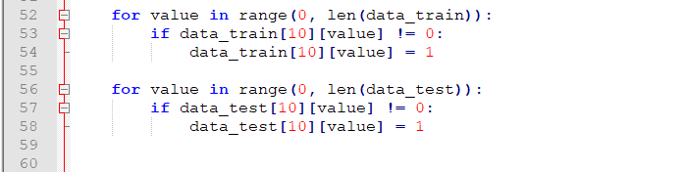
5) The program assigns the names to the variables.
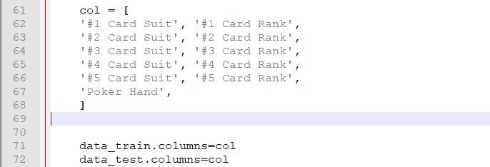
6) The program creates the variables with testing and training values (y_train and y_test , respectively) and the variables to be trained and tested (x_train and x_test , respectively).
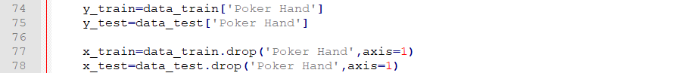

7) In the first stage, the classification is done by Decision Tree Classifier. Decision Tree Classification is done by DecisionTreeClassifier() got from sklearn.tree package. More information can be read here: https://scikit-learn.org/stable/modules/generated/sklearn.tree.DecisionTreeClassifier.html

Only changed default parameter for the homework purpose is criterion='entropy' , because by the default, DecisionTreeClassifier() uses criterion='gini' . After creating the variable, it builds the decision tree from the training set (x_train and y_train , respectively) by DecisionTreeClassifier.fit( x_train , y_train ) method in the next line. Then, it tries to predict the values from the test set by DecisionTreeClassifier.predict( x_test ) method. The accuracy is rounded till 3 digits after zero by metrics.accuracy_score(y_test, y_pred_decision_tree) from sklearn package (More information can be read here: https://scikit-learn.org/stable/modules/classes.html?highlight=metrics#module-sklearn.metrics) and is printed on the screen.
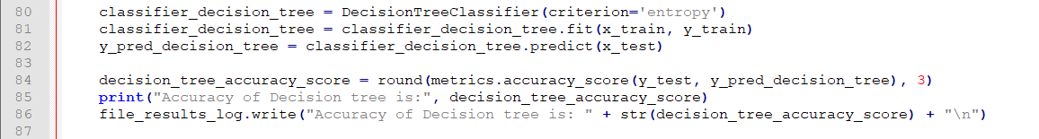
7) In the second stage, the classification is done by AdaBoost Classifier. AdaBoost Classification is done by AdaBoostClassifier() got from sklearn.ensemble package. More information can be read here: https://scikit-learn.org/stable/modules/generated/sklearn.ensemble.AdaBoostClassifier.html

The AdaBoost Classifier is loaded as AdaBoostClassifier(base_estimator=Perceptron(), n_estimators=15, algorithm='SAMME'). The base_estimator by default is DecisionTreeClassifier with max_depth=1, so according to our requirements, we have to define the weak classifier as Perceptron(). The Perceptron() is loaded from sklearn.linear_model package with default values (More information can be read here: https://scikit-learn.org/stable/modules/generated/sklearn.linear_model.Perceptron.html). The n_estimators is the number of estimators by which AdaBoost is classified. Since we need 15 perceptrons according to our requirements, n_estimators made equal to 15. algorithm='SAMME' is used as discrete boosting algorithm, since our weak classifier doesn’t support probability values, which doesn’t allow us to use default algorithm 'SAMME.R' .

Other problem is that if the values of perceptron is worse than the random values,
it provides an error ValueError: BaseClassifier in AdaBoostClassifier ensemble is worse than random, ensemble can not be fit. To avoid it, AdaBoost_with_15_perceptron_accuracy_score = 0 variable, while loop with try and except block are created. The loop executes until the accuracy score remains 0.

After creating the variable, it builds the AdaBoost classifier from the training set (x_train and y_train , respectively) by AdaBoostClassifier.fit( x_train , y_train ) method in the next line. Then, it tries to predict the values from the test set by AdaBoostClassifier.predict( x_test ) method. The accuracy is rounded till 3 digits after zero by metrics.accuracy_score(y_test, y_pred_decision_tree) from sklearn package (More information can be read here: https://scikit-learn.org/stable/modules/classes.html?highlight=metrics#module-sklearn.metrics) and is printed on the screen.

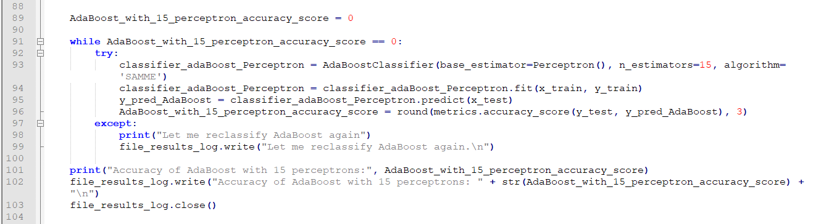
8) In the final stage, the image is created, labeled, saved (as “comparision.png” file) and opened by the program. This done by matplotlib.pyplot package. The program finishes only if the image window is closed:

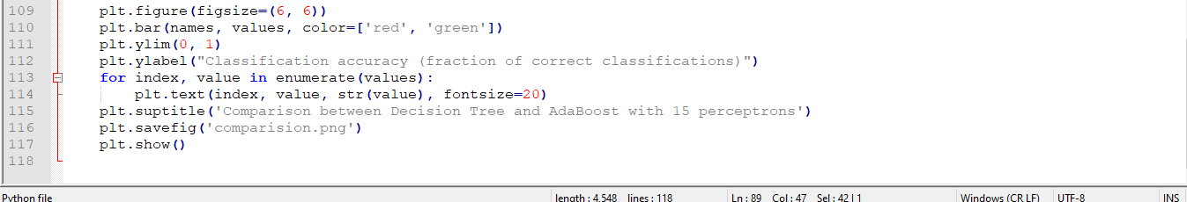
For example, the resulting image below describes that the classification accuracy (in the graph, the fraction of correct classifications. To get percents, simply multiply every value to 100) of Decision Tree Classifier is significantly higher than the AdaBoost Classifier with 15 perceptrons. Despite the accuracy of AdaBoost fluctuates from execution to execution, the difference in percents usually between 6-17%. In other words, Decision Tree Classifier is 6-17% more accurate.

